# **TOTAL MARKS:70 DURATION: 4 HOURS**

**General Instructions:**

1. *Students are not required to create tables/schema for any question.*
2. *Students may create tables if it helps them solve the problem, but marks are allocated only for the queries.*
3. *Students are required to follow the exact same nomenclature provided in the ER/Table Design Schema including Table Name, Column Name and any Constraints.*
4. *Please follow the same order as in question paper for answering questions.*

**SECTION A: 20 MARKS**

1. Write the uses cases of IN and EXISTS keywords? **(5 Marks)**
2. What is Shared lock and Deadlock? **(5 Marks)**
3. Explain the need for Transaction processing. Also explain the keywords used for it. **(5 Marks)**
4. Explain how the Repeatable Read Isolation level works with an example. **(5 Marks)**

**SECTION B: 20 MARKS**

1. As the owner of a company, it is your duty to monitor your employees. Consider two tables from the database. Identify the employees who were recruited by Smith and those employees for whom no information is available for the recruiter. (Solve Using SubQueries) **(5 Marks)(Use Table:- employee, recruiter)**

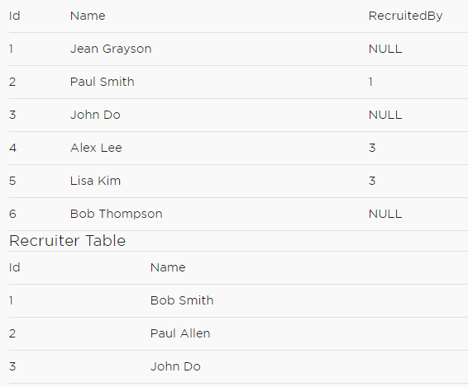

1. Consider the tables below.
   1. Write a Query to display the names and the total commission of all the salesman**.**

**Note:** Commission to be calculated as total Order amount*CommissionRate. One salesperson would have done multiple sales. **(5 Marks)**

* 1. Write a Query to display the names of all the salesman who did not sell to the customers located in the city ‘Austin’ **(5 Marks) (Use Tables: Salesperson, Customer, Sales_Orders)**

Salesperson

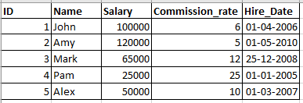

Customer

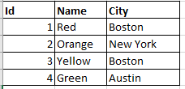

Sales_Order

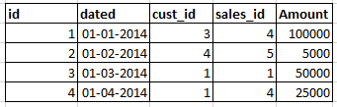

1. Consider the below tables and answer the following Question.

Write a Query to display the full names of the workers who Earn a salary that is less than the average salary of his department. **(5 Marks)**

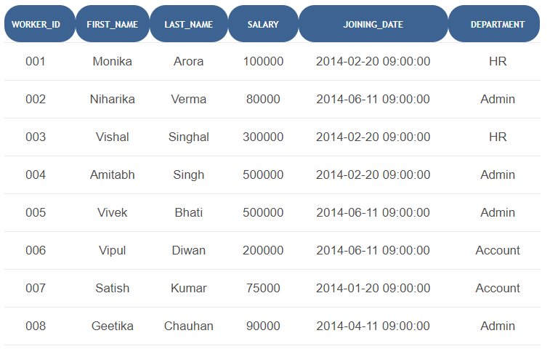

**SECTION C: 30 MARKS**

**Scenario:**

How to know if an app is successful? The below metrics are used to understand an Apps success.

**Metrics:**

1. **Number of users (User engagement)** - The first measure of success for an app is how many people actually download and intend to use the app. This is your initial look at user engagement since your first goal should be to achieve a broad user base.
2. **Source of the installation** - future channels for advertising and future marketing efforts
3. **Activation Rate -** This is the percentage of people who downloaded the app who actually launch it for use.
4. **Daily Active Users (DAU)** - This number will tell you whether people are using the app and how many people find your app indispensable. The Metric tells you each individual using the app, not the number of sessions. So each person is counted once, whether they use the app once a day or many times a day.
5. **Monthly active users (MAU)** - the unique number of people who use the app over the course of a specific month, or the prior 30 days. It will even break it down into four segments: 1-day, 7-day, 14-day, and 30-day active users. These are unique users who opened sessions on the app over the timeframe selected.

**Table: GooglePlayStore**

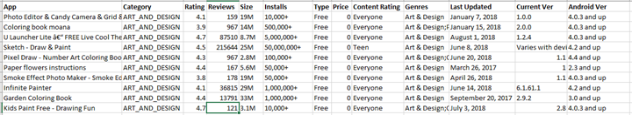

**Table: User_Session_Data**

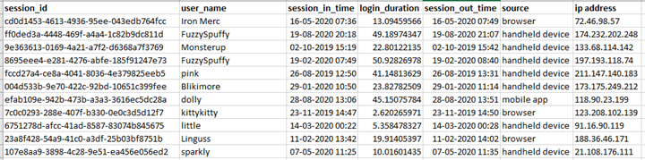

1. An Analyst wants to know the users who have logged in for the maximum amount of duration in the past month. What would be the query to rank and display the 50 users based on their total login durations? The user with the maximum duration of login would have rank 1 and so on.

(Consider the month for which the data was captured last.)

**(use table:- User_Session_Data)(10 Marks)**

1. An Analyst wants to know the users who have less than average screen time(login time) of all users. What would be the query to display such a report? Sort the report in ascending order of screen time. **(use table:- User_Session_Data)(10 Marks)**
2. An Analyst wants to categorise the Apps based on the popularity. The metric used to measure the popularity is rating. Along with the details of the app, display a new column which categorises the App as

HIGHLY POPULAR for apps with rating above 4

POPULAR for apps with rating between 3 and 4

MODERATELY POPULAR for apps with rating between 2 and 3

UNPOPULAR for apps with rating less than 2 till 0

NONE for apps with no ratings.

**(use table:- GooglePlayStore) (10 Marks)**